

**PROBLEM STATEMENT**

**Balamurugan. S** – **2022103544**

**Shakith. A** – **2022103545**

**Team Number** : 7

**Semester** : 4

**Batch** : P

**Department**  : CSE

**Submitted On** : 23/05/2024

**Submitted To** : Dr.S.Renugadevi, DCSE, Anna University

**TicketsTrail**

**Online Movie Ticket Booking System**

**CS6106**

**Database Management Systems Report**

Buying movie tickets the old way can be a hassle: long lines, uncertain seat availability, and limited information. Our project aims to revolutionize the online movie ticket reservation experience by introducing innovative features and enhancing user experience.

We propose to offer advanced search options, seamless integration with nearby theaters, and a simplified yet powerful user interface. This will not only make booking movie tickets more convenient but also provide users with a richer experience. Additionally, our platform will support theater administrators by providing real-time statistics, such as revenue insights, peak hours and days, user preferences, and popular genres.

Our goal is to surpass existing platforms by delivering an enhanced user experience, making the process of booking movie tickets more efficient and enjoyable, while simultaneously equipping theater administrators with essential tools for managing theaters and movies, informed with decision-making and improved profitability.

**TECHNOLOGIES USED**

* HTML, CSS, Javascript, Bootstrap
* mySql - Xampp
* Flask and Python

**KEY FEATURES**

* Optimized Search for the movies.
* Theater suggestion based on user’s location.
* Enhanced and Simple UI/UX.
* Theater’s revenue**.**
* Movie’s revenue.
* Administrating Theaters, Movies and Screenings of Movies.

**ENTITIES**

* **Users -** User_Id, User_Name, Age, Gender, City, Email, Password, Phone, Registration date, salt, role
* **Theaters -** Theater_Id, Theater_Name, Location
* **Screens -** Theater_Id, Screen_id, Screen_Name, Elite_Seats, Premium_Seats
* **Movies -** Movie_Id, Movie_Name, Genre, Rating, Description, URL, Run time, Run date
* **Bookings** - Booking_Id, User_Id, Movie_Id, Theater_Id, Screen_id, Date, Show_Time, No_of_Elite_Seats, No_of_Premium_Seats, Price
* **Seats_Booked** - Booking_Id, Seats

**RELATIONS**

* **Movies_On_Theaters** - Movie_Id, Theater_Id, Screen_Id, Date, Show_Time
* Theater is related to Screens
* Users, Theaters, Movies and Screens are related via Bookings.
* Bookings and Seats_Booked are related to each other by the booking_id.

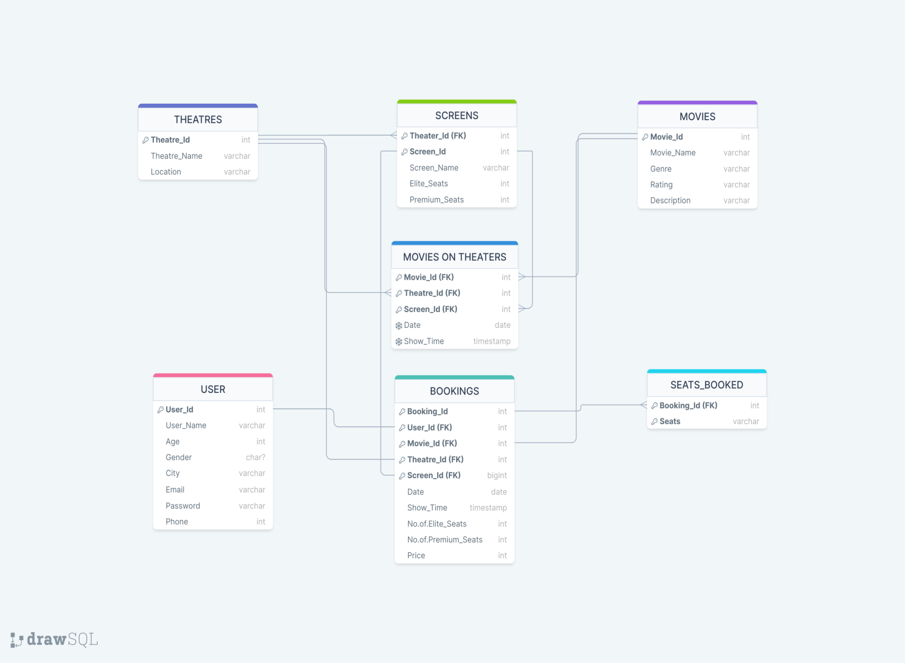**SCHEMA_DIAGRAM**

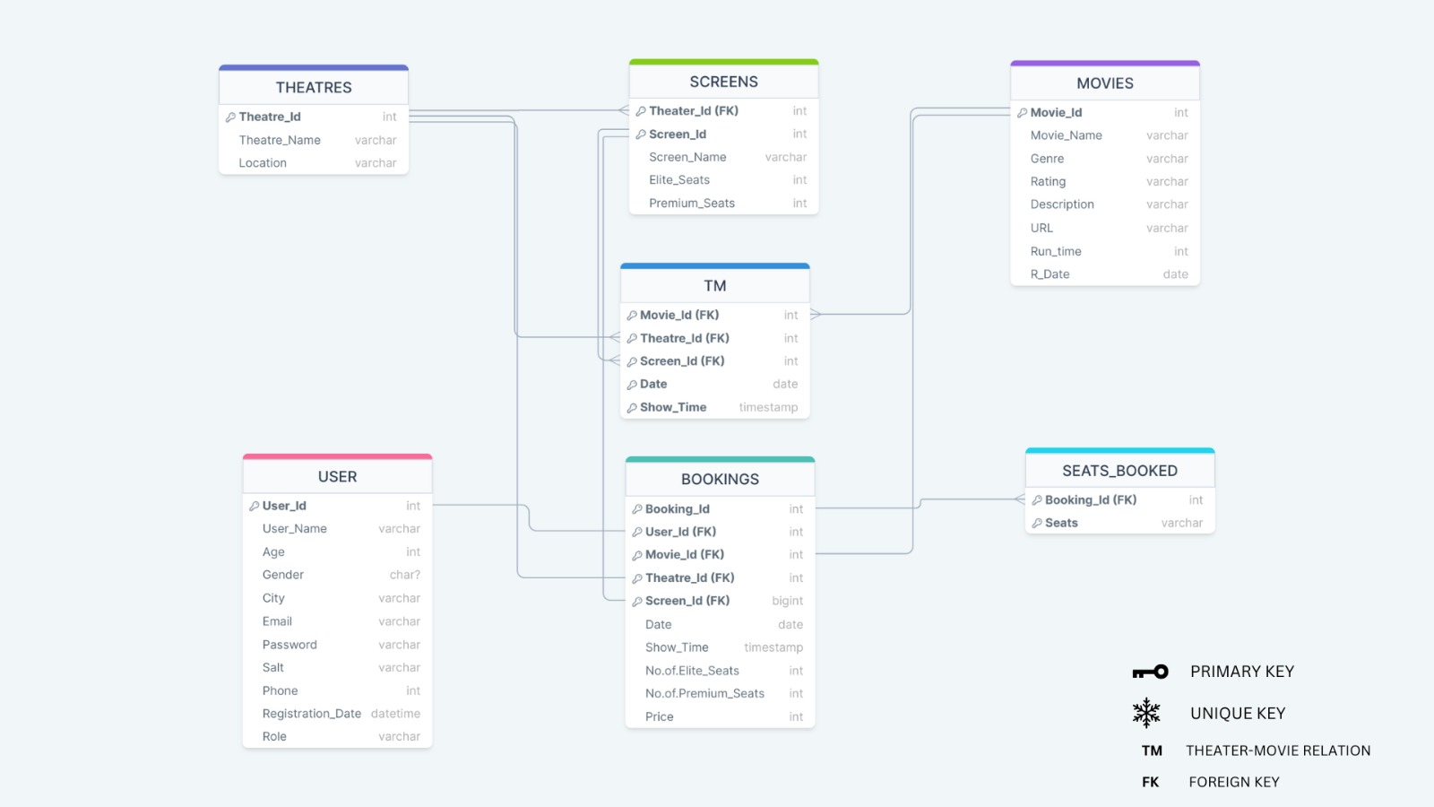

URL varchar

R_time time

R_date date

Reg_date date

Role varchar

Salt varchar

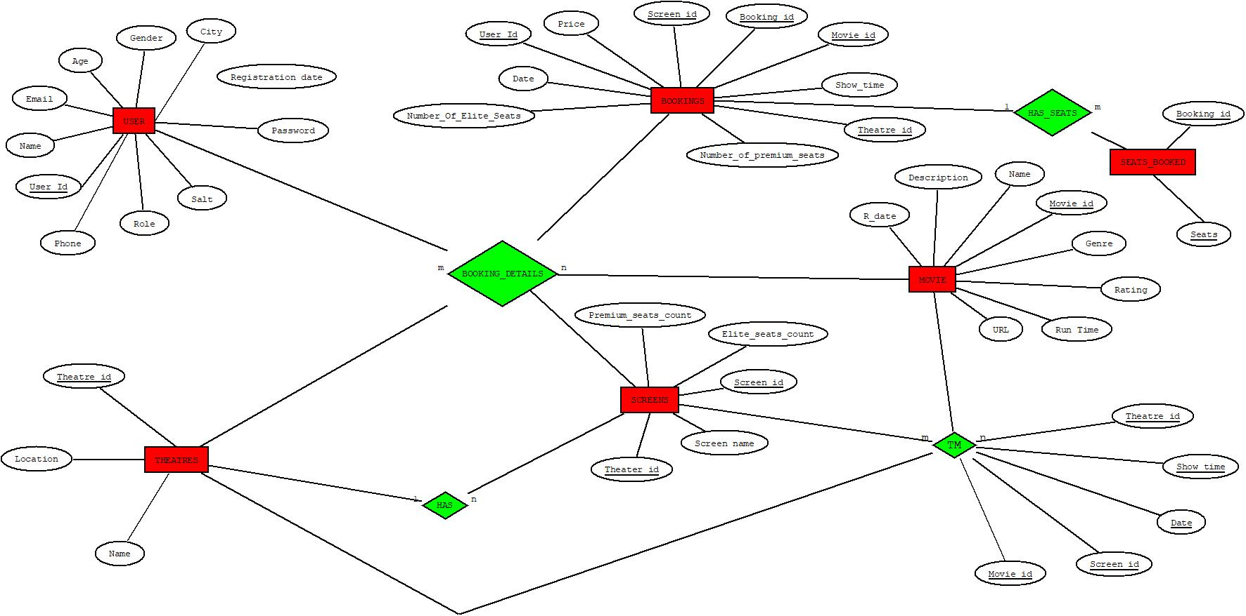 **ER DIAGRAM**

**IMPLEMENTATION**

Front End

**USER SIDE**

**a. Login**

This consists of the login page, which serves as a gateway to enter the ticketing website. Users can either log in or sign up if they don’t have an account.

Here the password is checked with the hashed value in the table. If the password matches, user goes to the home page.

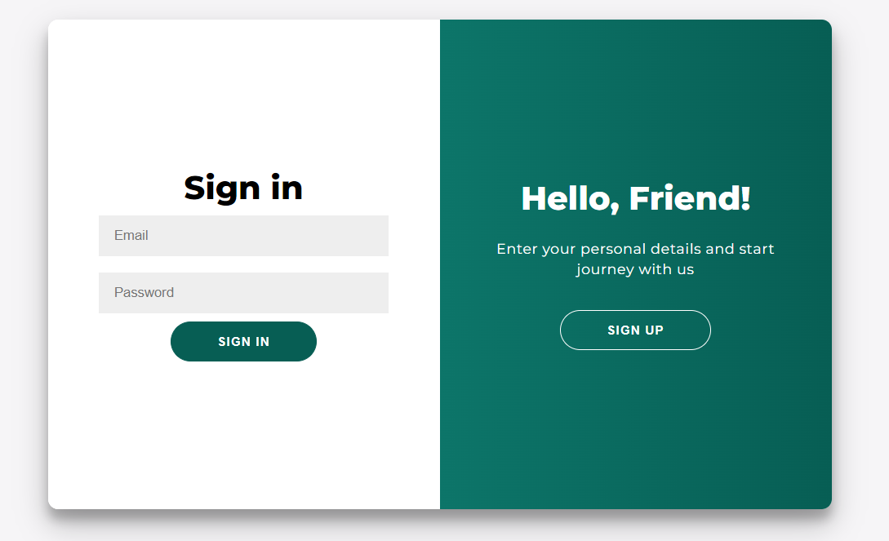

Figure 1: The website with login page

**b. Sign-Up**

New user details are stored in database for future reference and logins. Data is stored in the “users” table. This is used to store information about the new users.

`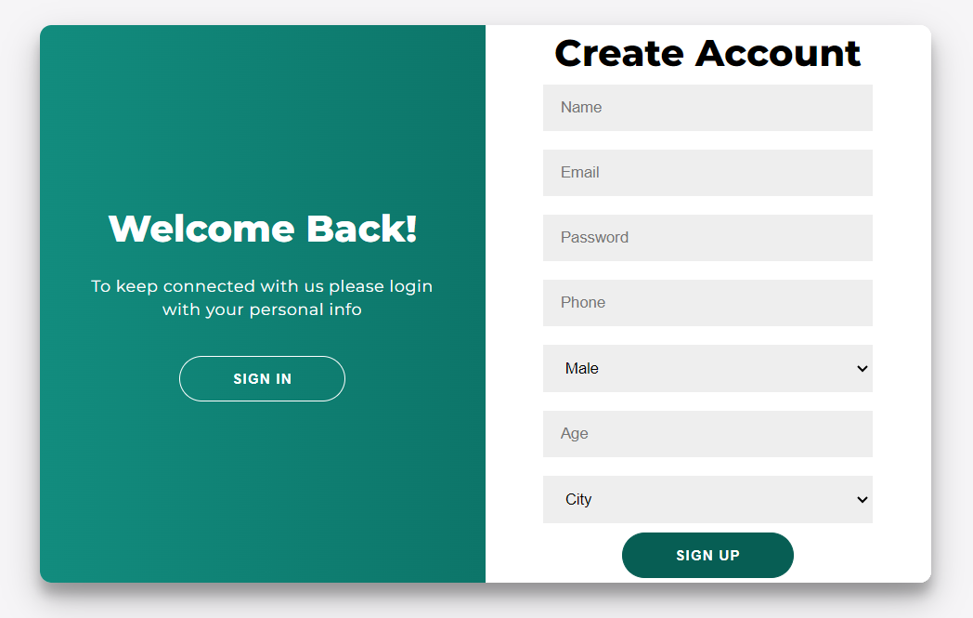

Figure 2: The website with signup page

**c. Homepage**

After logging in, shows the list of movies available to book from.

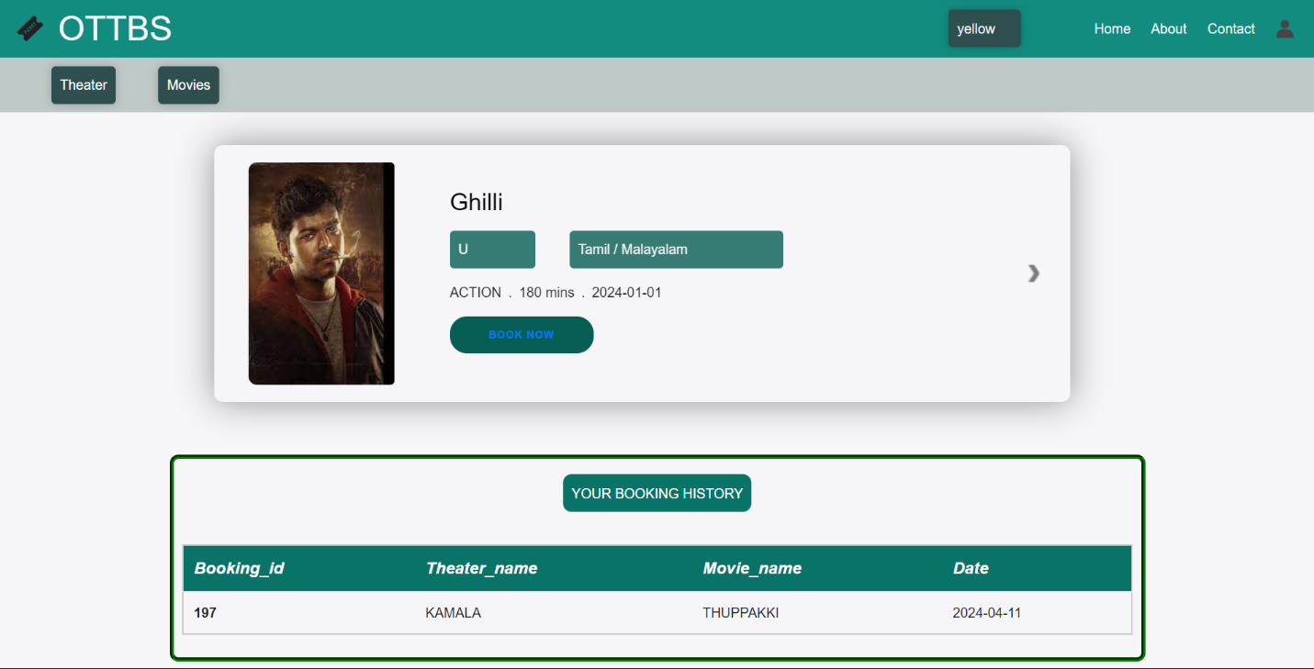

**d. Booking Options**

**1. Theater based selection.**

Allows user to select theatre to book.

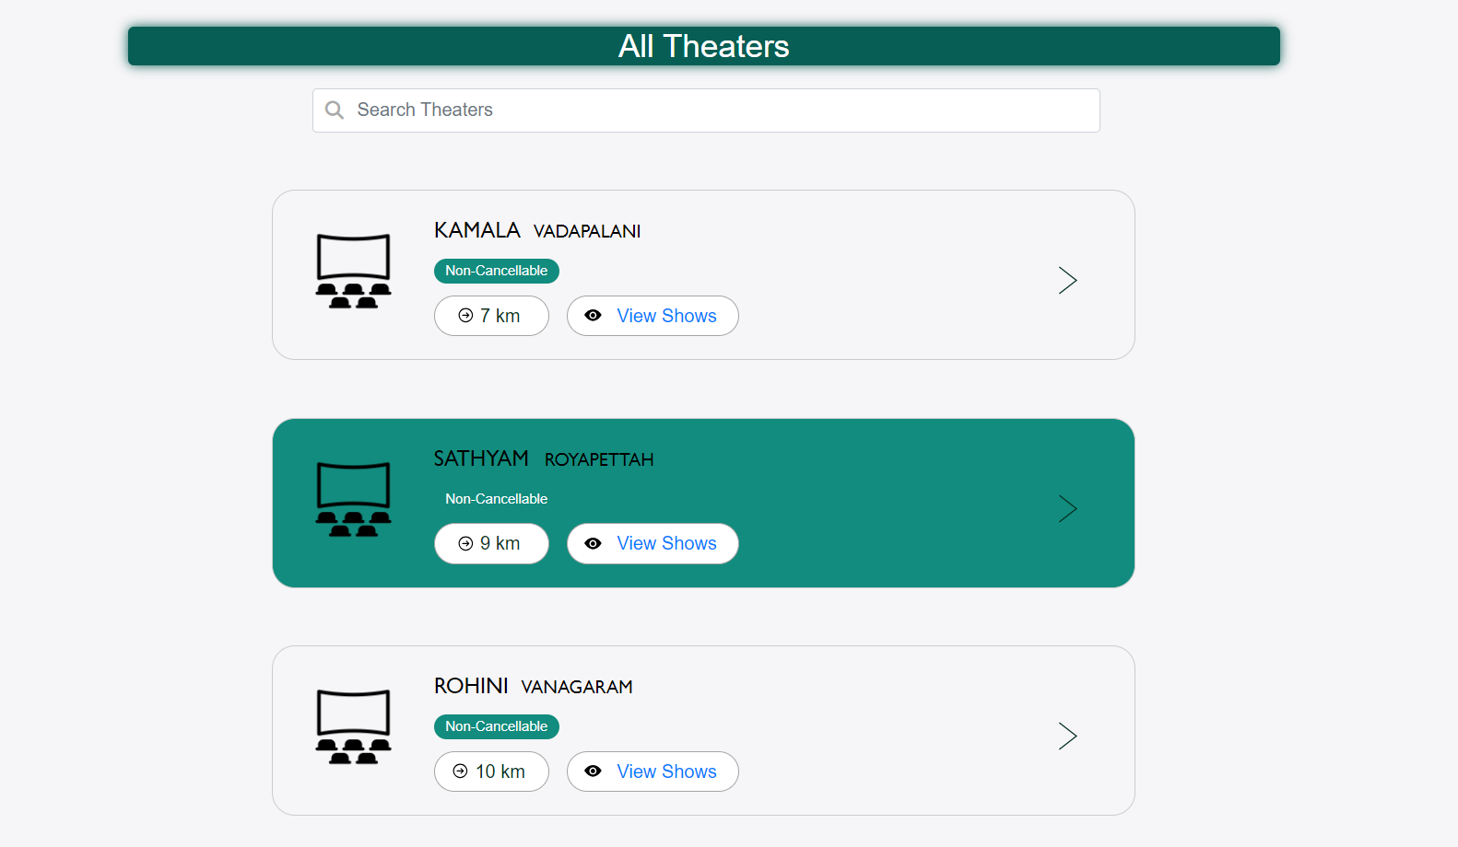If the user clicks on the theaters on the home page, following theater page will be displayed according to the user’s nearby location.

Figure 4: Theater page

If the user clicks on the view shows on the movie page, following movie page will be displayed.

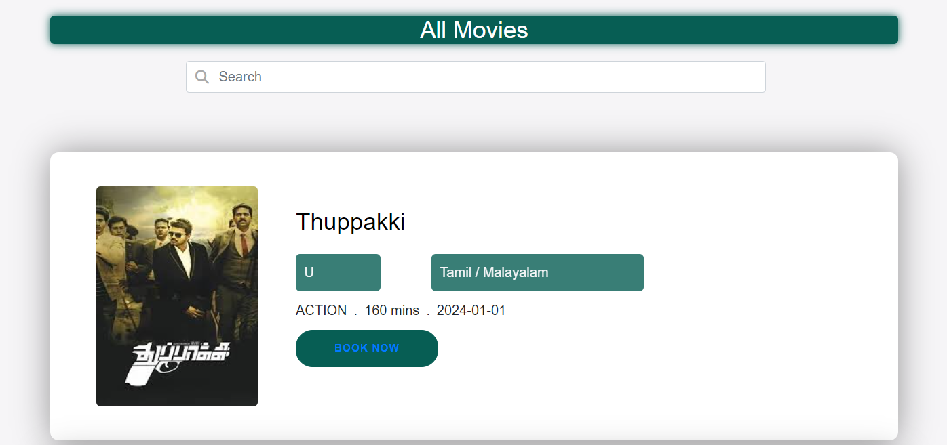Figure 5: Movie page

Onclicking the Book Now button in the Movie page, the following page will page

will be displayed to select the screen and the timings.

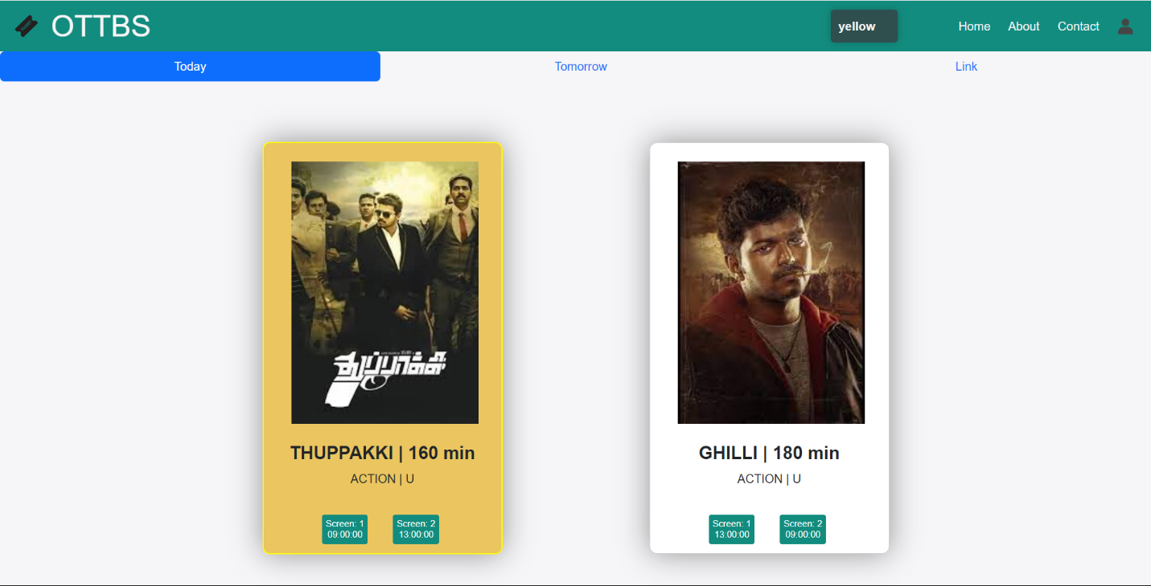

Figure 6: Screen Selection Page

**2. Movie based Selection:**

 Similarly by clicking on the Movie, the (figure5) Movie page will be displayed.

Figure 5: Movie page

After clicking on the book show button, the theaters page with

all theaters displaying the movies will be displayed.



Then, clicking on the view shows, the page with screen and time selection will be displayed.



Figure 6: Screen Selection Page

**e. Seat selection :** Here after, the steps will be common to both theater and movie selection mode. By clicking on any one of the screen and time button, the following seat selection page will be displayed.

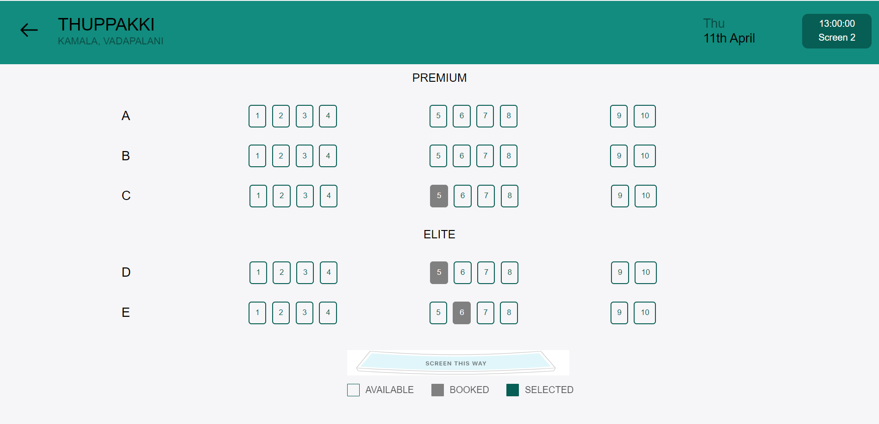

Already booked seats will be in grey color, If the user selects the seats,

a component with total seats and continue will toggled.

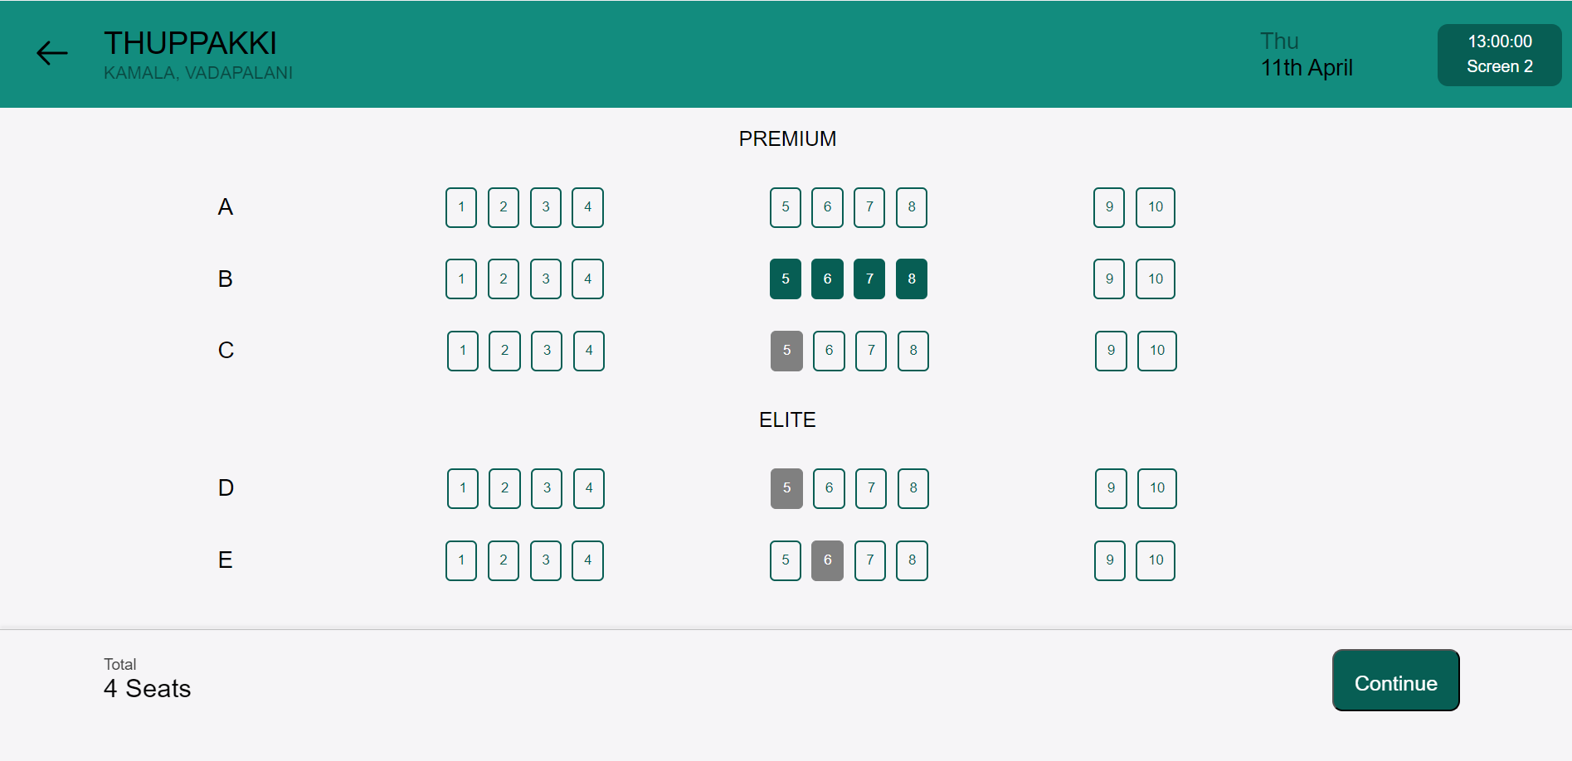

Figure 8: Seat Selection Page

**f. Payment :** By Selection the continue button, following page will be payment page with the ticket details on the left side will be displayed.

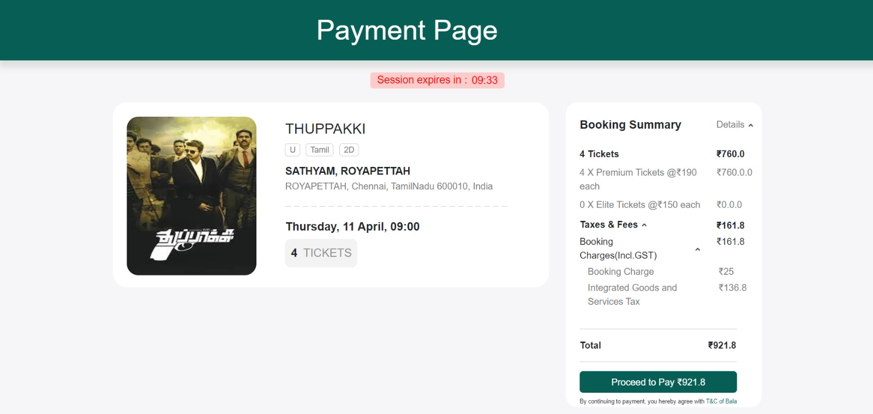

Figure 9: Payment Page

**g. Ticket :** By clicking on the proceed to pay, the user will pay the amount and the ticket will be generated along with QR code and that terminates the user side.

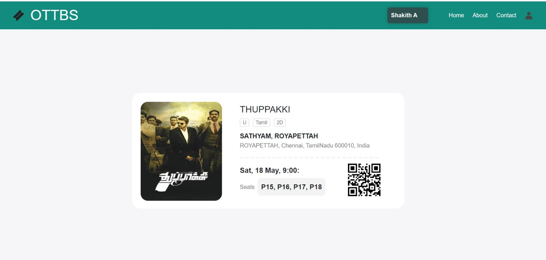

Figure 10: ticket generation Page

**ADMIN SIDE:**

1. 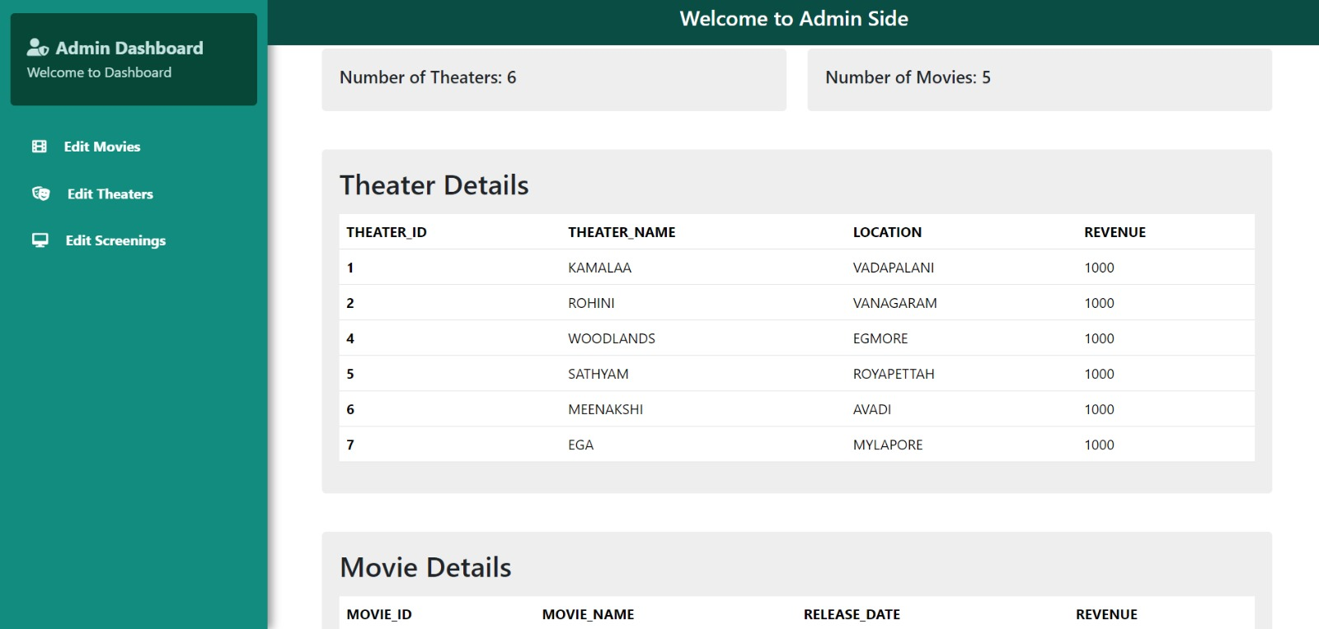The admin landing page.

The dashboard page will show theater details and movie details.

1)By clicking on the Edit movies, a page with create, update and delete movies will be displayed.

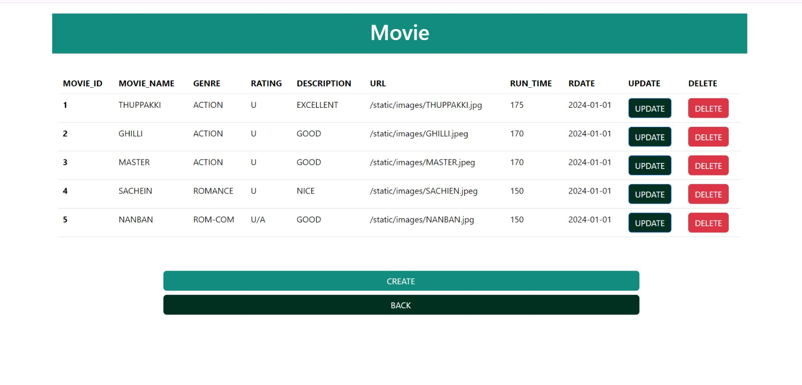

2) Inserting into the movie table from admin side.

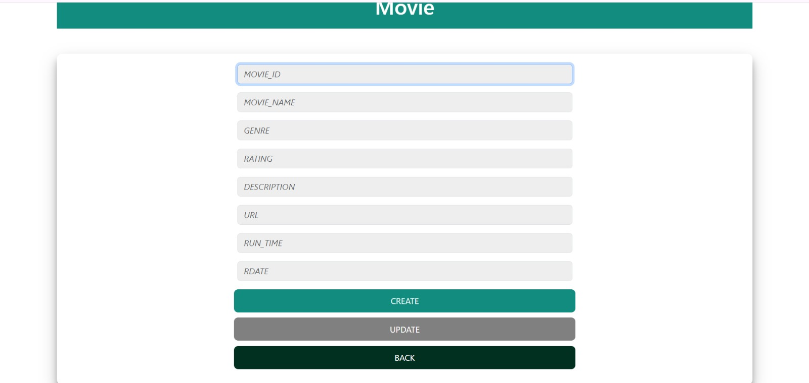

3) Updating the movie table

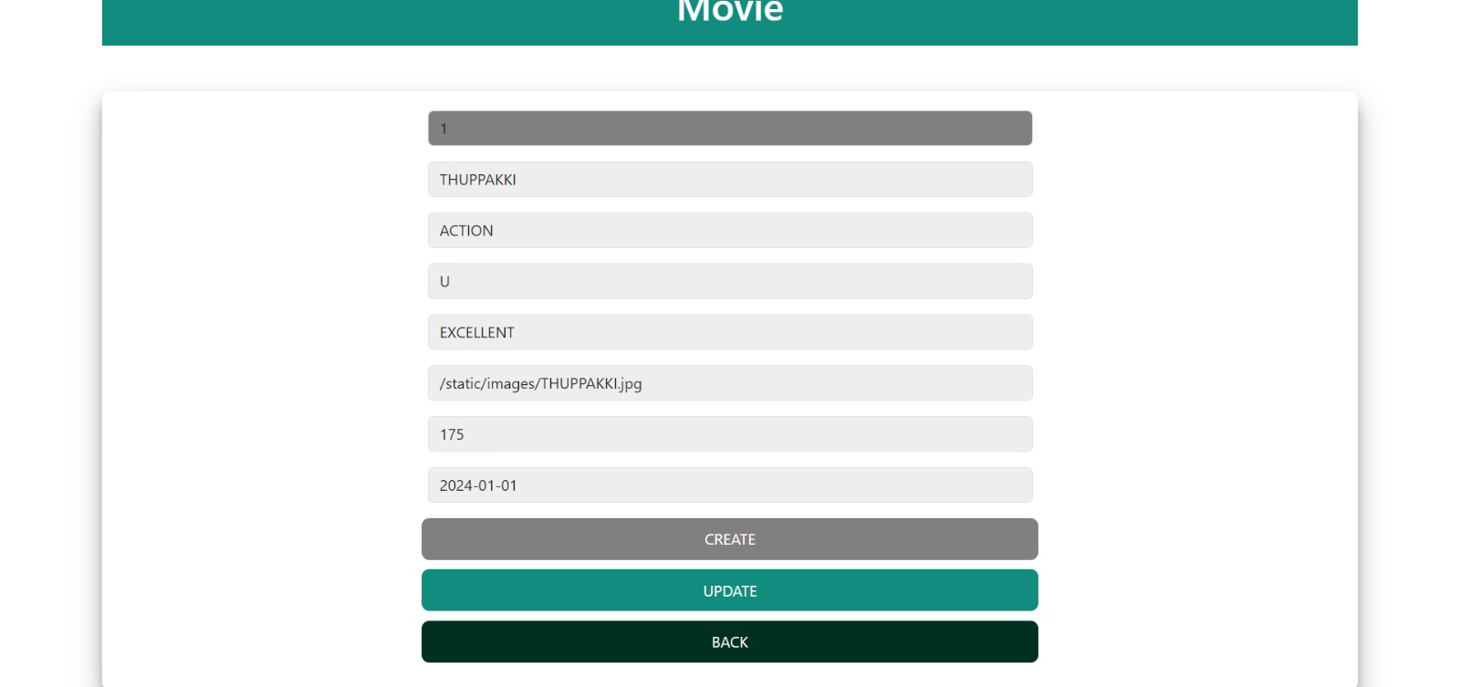

1. Theater details page

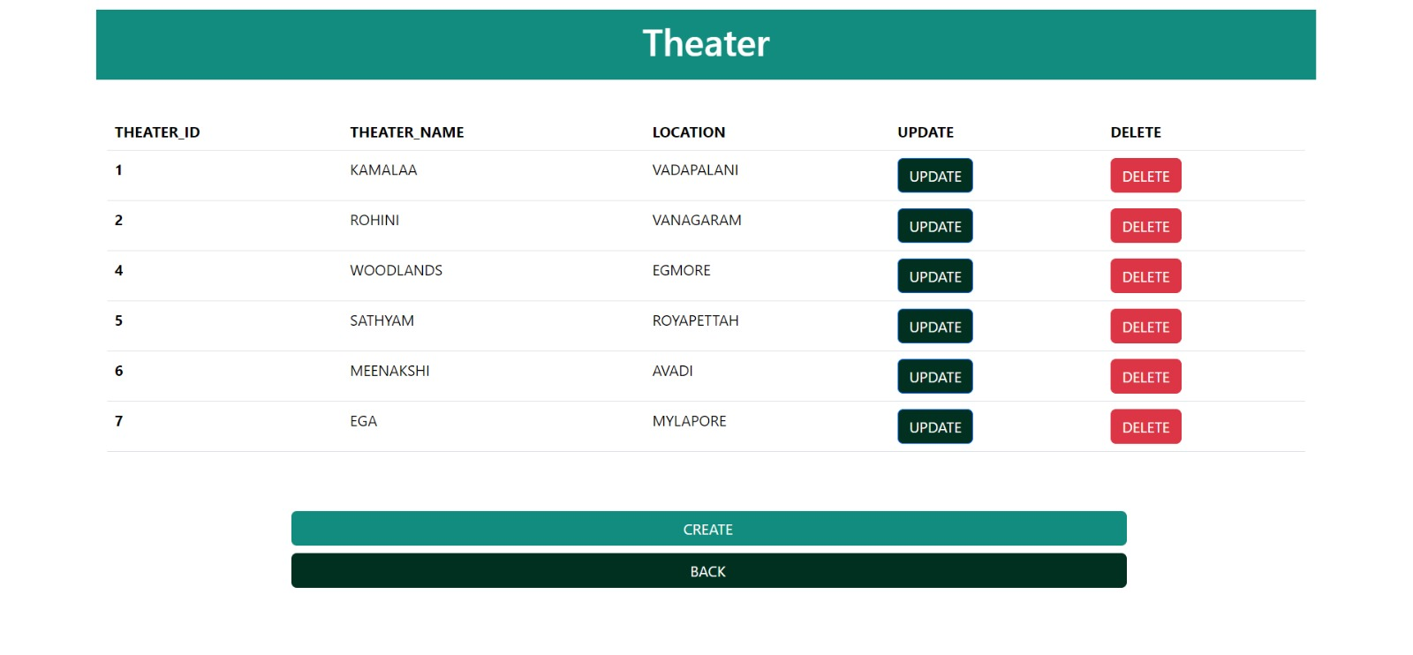

1. 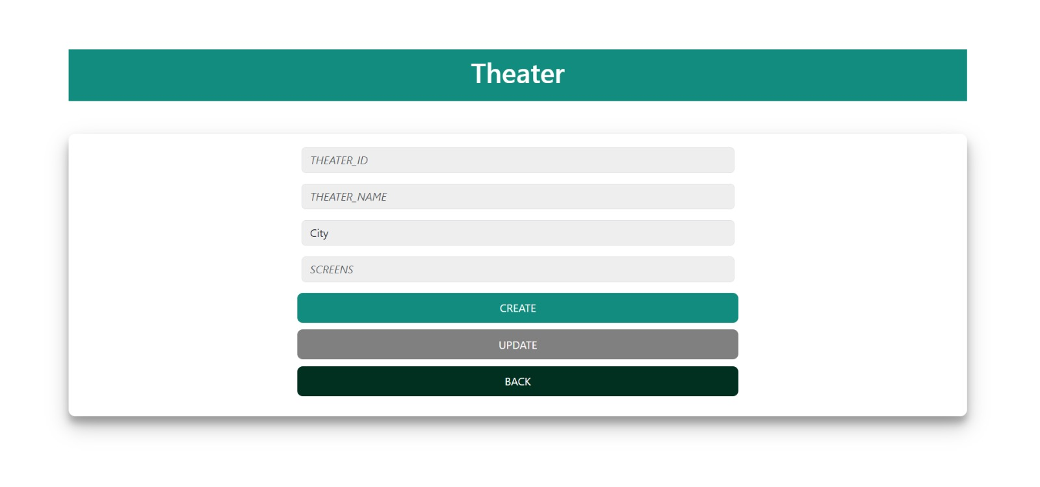Theater table insertion from the admin side,
2. Theater table updation page,

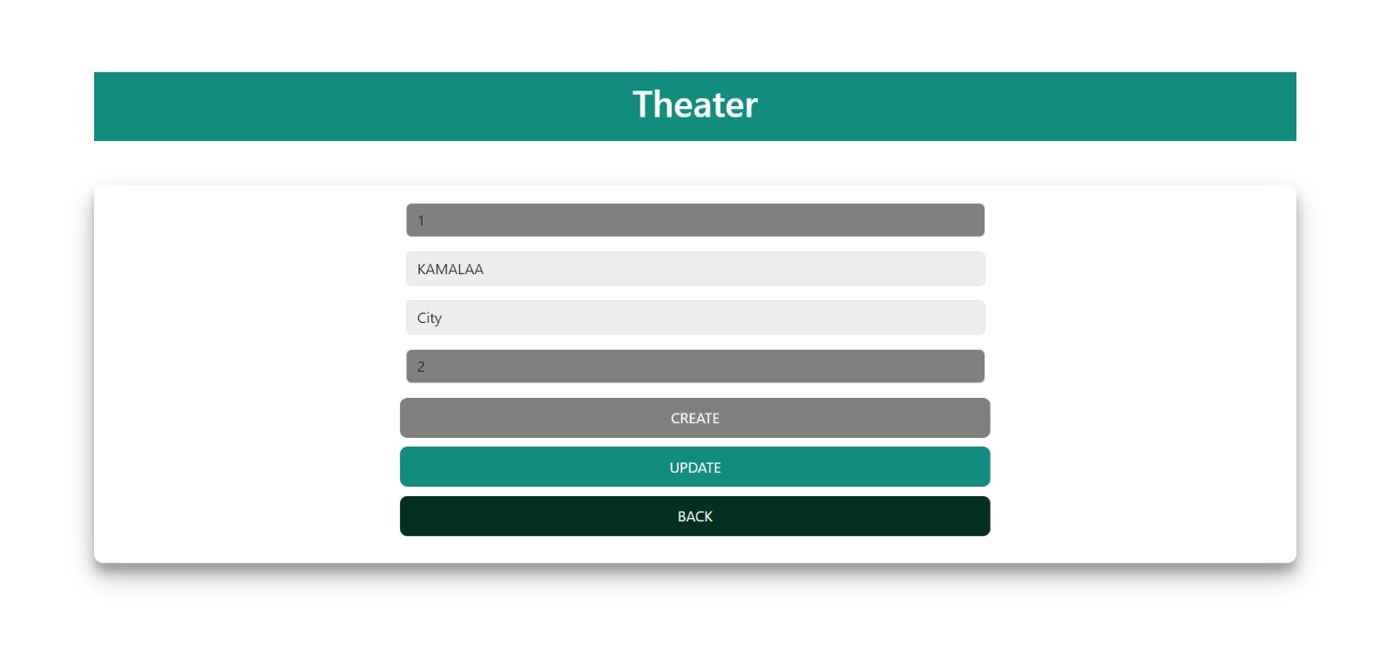

1) The movies on theaters table.

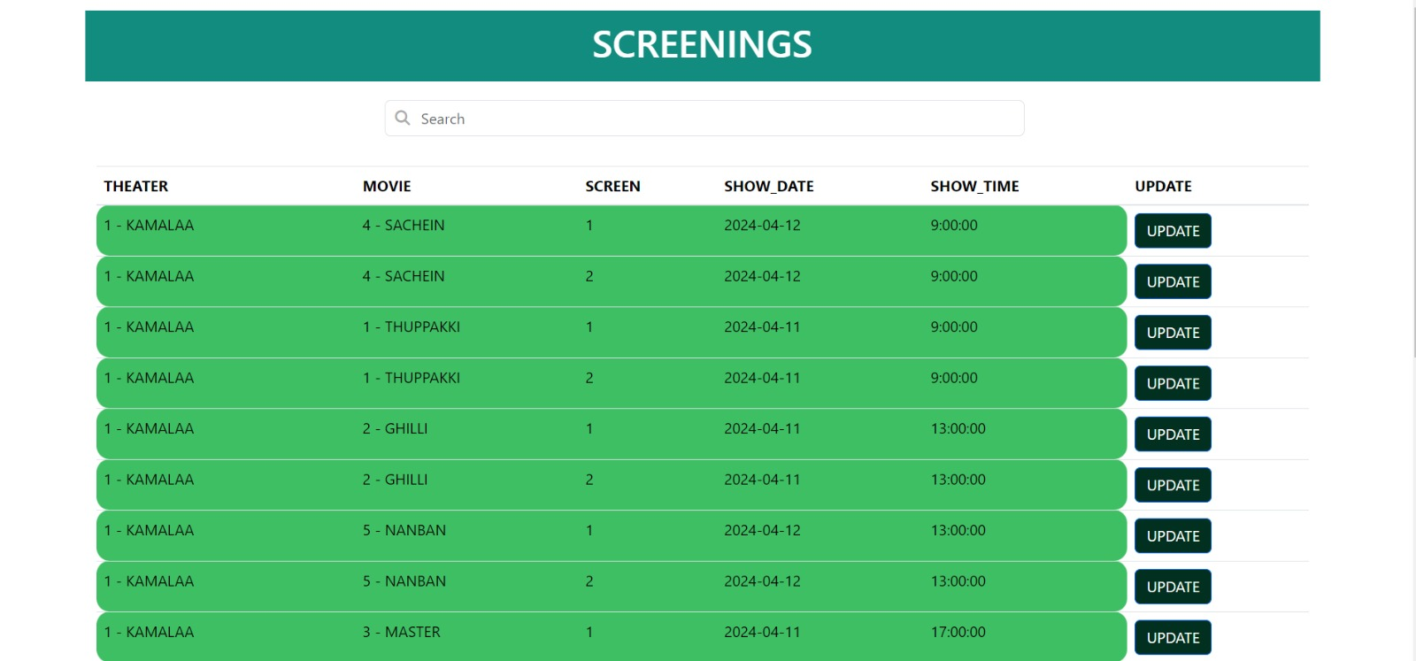

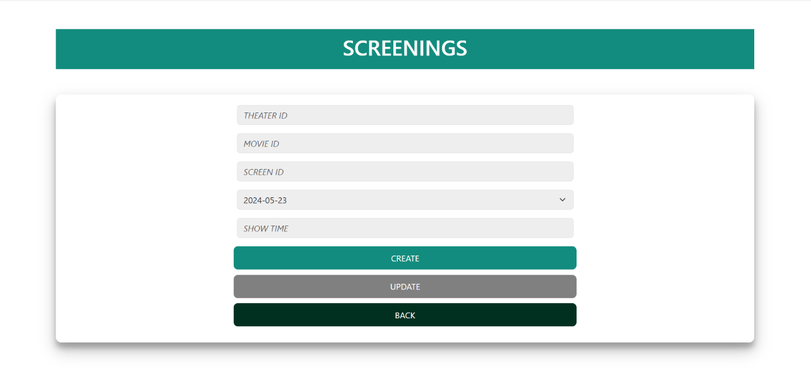2) Insertion of the movies on theaters table

1. Updation of the movies on theaters table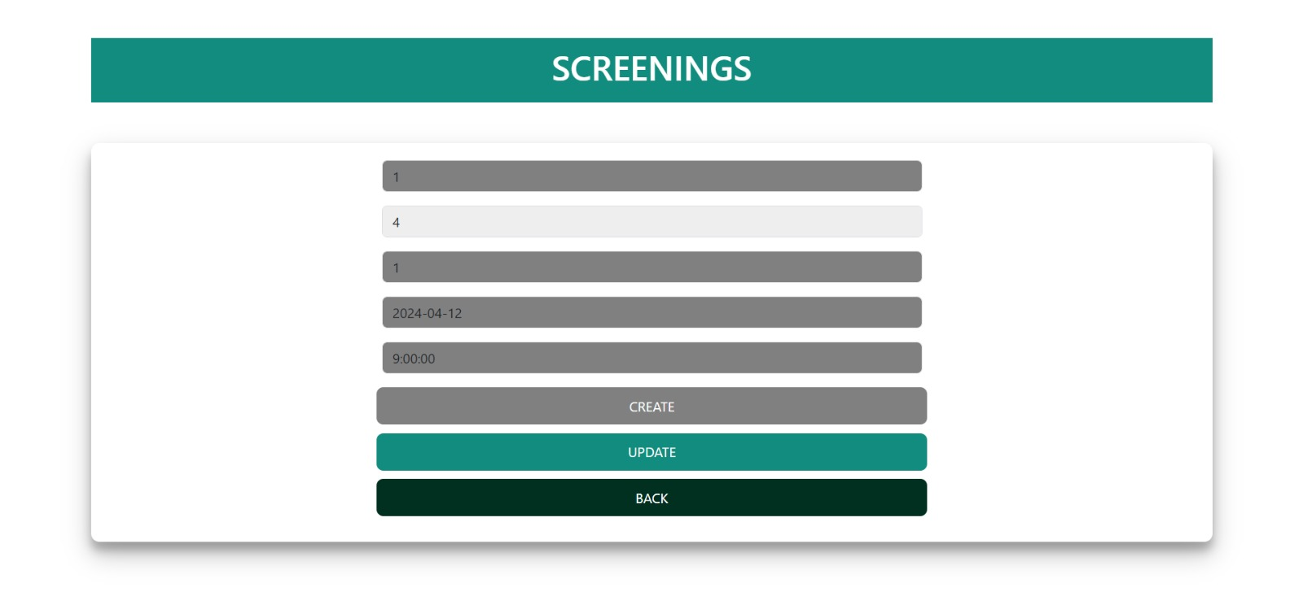

**Triggers, Procedures, Functions and Cursors**

--TO NOT UPDATE RUNTIME AFTER SCHEDULING

DELIMITER //(TRIGGER 1)

CREATE OR REPLACE TRIGGER before_runtime_update_on_scheduled_movies

BEFORE UPDATE ON movies FOR EACH ROW

BEGIN

DECLARE movie_exists INT;

IF NEW.run_time != OLD.run_time THEN

-- Check if the movie is present in the TM table

SELECT COUNT(*) INTO movie_exists

FROM TM

WHERE MOVIE_ID = NEW.MOVIE_ID;

-- If the movie is present in the TM table, prevent the update

IF movie_exists > 0 THEN

SIGNAL SQLSTATE '45000'

SET MESSAGE_TEXT = 'Cannot update run time of a movie scheduled for screening.';

END IF;

END IF;

END //

DELIMITER ;

--ENSURES THAT IF NEW MOVIE IS INSERTED IT IS ATLEAST INSERTED AFTER 1 HOUR AFTER ITS PREVIOUS MOVIE GETS OVER (SHOW_TIME BASED)

--AND IT IS ATLEAST INSERTED AFTER 1 HOUR BEFORE THE NEXT MOVIE STARTS.

DELIMITER //(TRIGGER 2)

CREATE OR REPLACE TRIGGER before_tm_insert_1hour_hibernation

BEFORE INSERT ON TM FOR EACH ROW

BEGIN

DECLARE prev_run_time TIME;

DECLARE prev_movie_start_time TIME;

DECLARE prev_movie_end_time TIME;

DECLARE new_run_time TIME;

DECLARE new_movie_start_time TIME;

DECLARE new_movie_end_time TIME;

DECLARE next_run_time TIME;

DECLARE next_movie_start_time TIME;

DECLARE next_movie_end_time TIME;

DECLARE prev_movieid INT;

DECLARE next_movieid INT;

DECLARE time_diff_before TIME;

DECLARE time_diff_after TIME;

SELECT TM.MOVIE_ID, SHOW_TIME

INTO prev_movieid, prev_movie_start_time

FROM TM

WHERE THEATER_ID = NEW.THEATER_ID

AND SCREEN_ID = NEW.SCREEN_ID

AND SHOW_DATE = NEW.SHOW_DATE

AND SHOW_TIME < NEW.SHOW_TIME

ORDER BY SHOW_TIME DESC

LIMIT 1;

SELECT TM.MOVIE_ID, SHOW_TIME

INTO next_movieid, next_movie_start_time

FROM TM

WHERE THEATER_ID = NEW.THEATER_ID

AND SCREEN_ID = NEW.SCREEN_ID

AND SHOW_DATE = NEW.SHOW_DATE

AND SHOW_TIME > NEW.SHOW_TIME

ORDER BY SHOW_TIME ASC

LIMIT 1;

SET prev_run_time = MAKETIME(CEIL((SELECT RUN_TIME FROM MOVIES WHERE MOVIE_ID = prev_movieid) / 60), 0, 0);

SET prev_movie_end_time = ADDTIME(prev_movie_start_time, prev_run_time);

SET new_run_time = MAKETIME(CEIL((SELECT RUN_TIME FROM MOVIES WHERE MOVIE_ID = NEW.MOVIE_ID) / 60), 0, 0);

SET new_movie_start_time = NEW.SHOW_TIME;

SET new_movie_end_time = ADDTIME(new_movie_start_time, new_run_time);

SET next_run_time = MAKETIME(CEIL((SELECT RUN_TIME FROM MOVIES WHERE MOVIE_ID = next_movieid) / 60), 0, 0);

SET next_movie_end_time = ADDTIME(next_movie_start_time, next_run_time);

SET time_diff_before = TIMEDIFF(new_movie_start_time, prev_movie_end_time);

SET time_diff_after = TIMEDIFF(next_movie_start_time, new_movie_end_time);

IF (time_diff_before < '01:00:00') THEN

SIGNAL SQLSTATE '45000' SET MESSAGE_TEXT = 'TIME GAP BETWEEN 2 SCREENINGS SHOULD BE ATLEAST 1 HOUR AFTER THE MOVIE ENDS.';

END IF;

IF (time_diff_after < '01:00:00') THEN

SIGNAL SQLSTATE '45000' SET MESSAGE_TEXT = 'TIME GAP BETWEEN 2 SCREENINGS SHOULD BE ATLEAST 1 HOUR AFTER THE MOVIE ENDS.';

END IF;

IF (time_diff_before = '00:00:00') THEN

SIGNAL SQLSTATE '45000' SET MESSAGE_TEXT = 'ANOTHER MOVIE IS SCREENED ENDS.';

END IF;

IF (time_diff_after = '00:00:00') THEN

SIGNAL SQLSTATE '45000' SET MESSAGE_TEXT = 'ANOTHER MOVIE IS SCREENED.';

END IF;

END//

DELIMITER ;

--TO NOT ADD 2 MOVIES AT SAME SCREEN, TIME, DATE, THEATER

DELIMITER //(TRIGGER 3)

CREATE TRIGGER prevent_duplicate_movie

BEFORE INSERT ON TM

FOR EACH ROW

BEGIN

DECLARE existing_movie_count INT;

SELECT COUNT(*)

INTO existing_movie_count

FROM TM

WHERE THEATER_ID = NEW.THEATER_ID

AND SCREEN_ID = NEW.SCREEN_ID

AND SHOW_DATE = NEW.SHOW_DATE

AND SHOW_TIME = NEW.SHOW_TIME;

IF existing_movie_count > 0 THEN

SIGNAL SQLSTATE '45000'

SET MESSAGE_TEXT = 'Cannot insert. Another movie is scheduled for the same theater, screen, date, and time.';

END IF;

END //

DELIMITER ;

--TO AUTO INCREMENT BOOKING ID (DOESN'T INCREASES EVEN IF ERROR OCCURS)(TRIGGER 4)

DELIMITER //

CREATE TRIGGER set_booking_id BEFORE INSERT ON bookings

FOR EACH ROW

BEGIN

DECLARE last_id INT;

SELECT MAX(booking_id) INTO last_id FROM bookings;

IF last_id IS NULL THEN

SET NEW.booking_id = 1;

ELSE

SET NEW.booking_id = last_id + 1;

END IF;

END //

DELIMITER ;

--TO INCREMENT USER ID(TRIGGER 5)

DELIMITER //

CREATE TRIGGER set_user_id BEFORE INSERT ON users

FOR EACH ROW

BEGIN

DECLARE last_id INT;

SELECT MAX(user_id) INTO last_id FROM users;

IF last_id IS NULL THEN

SET NEW.user_id = 1;

ELSE

SET NEW.user_id = last_id + 1;

END IF;

END //

DELIMITER ;

--PROCEDURE TO DELETE THEATER IF MOVIE IS NOT SCREENED

DELIMITER //(PROCEDURE)

CREATE OR REPLACE PROCEDURE DELETE_THEATER (IN theater_id_param INT)

BEGIN

DECLARE theaters_exist INT;

-- Check if the theater exists in the TM table

SELECT COUNT(*) INTO theaters_exist FROM TM WHERE THEATER_ID = theater_id_param;

-- If the theater does not exist in the TM table, delete its screens and then delete the theater

IF theaters_exist = 0 THEN

BEGIN

DELETE FROM SCREENS WHERE THEATER_ID = theater_id_param;

DELETE FROM THEATERS WHERE THEATER_ID = theater_id_param;

END;

ELSE

SIGNAL SQLSTATE '45000'

SET MESSAGE_TEXT = 'Cannot insert. Another movie is scheduled for the same theater, screen, date, and time.';

END IF;

END //

DELIMITER ;

--FUNCTION TO RETURN REVENUE OF EACH THEATER

DELIMITER //(FUNCTION 1)

CREATE OR REPLACE FUNCTION calculate_theater_revenue(theater_id_param INT)

RETURNS DECIMAL(10, 2)

BEGIN

DECLARE elite_total DECIMAL(10, 2);

DECLARE premium_total DECIMAL(10, 2);

DECLARE total DECIMAL(10, 2);

-- Calculate total price for elite seats

SELECT COALESCE(SUM(no_of_elite_seats) * 150, 0) INTO elite_total

FROM BOOKINGS

WHERE theater_id = theater_id_param;

-- Calculate total price for premium seats

SELECT COALESCE(SUM(no_of_premium_seats) * 190, 0) INTO premium_total

FROM BOOKINGS

WHERE theater_id = theater_id_param;

-- Add total price for elite and premium seats

SET total = elite_total + premium_total;

-- Return the total price

RETURN total;

END //

DELIMITER ;

--FUNCTION TO RETURN REVENUE OF EACH MOVIE

DELIMITER //(FUNCTION 2)

CREATE OR REPLACE FUNCTION calculate_movie_revenue(movie_id_param INT) RETURNS DECIMAL(10, 2)

BEGIN

DECLARE total_revenue_1 DECIMAL(10, 2);

DECLARE total_revenue_2 DECIMAL(10, 2);

DECLARE total_revenue DECIMAL(10, 2);

-- Calculate revenue for elite seats

SELECT COALESCE(SUM(no_of_elite_seats) * 150, 0) INTO total_revenue_1

FROM BOOKINGS

WHERE movie_id = movie_id_param;

-- Add revenue for premium seats

SELECT COALESCE(SUM(no_of_premium_seats) * 190, 0) INTO total_revenue_2

FROM BOOKINGS

WHERE movie_id = movie_id_param;

-- Calculate total revenue

SET total_revenue = total_revenue_1 + total_revenue_2;

-- Return the total revenue for the movie

RETURN total_revenue;

END //

DELIMITER ;

--CURSOR TO CALCULATE ACTIVE USERS

DELIMITER //(CURSOR 1)

CREATE OR REPLACE PROCEDURE active_users()

BEGIN

DECLARE done INT DEFAULT FALSE;

DECLARE user_count INT DEFAULT 0;

DECLARE user_id_current INT;

DECLARE user_cursor CURSOR FOR

SELECT DISTINCT user_id FROM BOOKINGS;

DECLARE CONTINUE HANDLER FOR NOT FOUND SET done = TRUE;

OPEN user_cursor;

read_loop: LOOP

FETCH user_cursor INTO user_id_current;

IF done THEN

LEAVE read_loop;

END IF;

SET user_count = user_count + 1;

END LOOP;

CLOSE user_cursor;

SELECT CONCAT('Total active users: ', user_count) AS user_count;

END//

DELIMITER ;

--CURSOR TO CALCULATE TOTAL MOVIES

DELIMITER //(CURSOR 2)

CREATE OR REPLACE PROCEDURE calculate_movie_count()

BEGIN

DECLARE done INT DEFAULT FALSE;

DECLARE movie_count INT DEFAULT 0;

DECLARE movie_id_current INT;

DECLARE movie_cursor CURSOR FOR

SELECT movie_id FROM MOVIES;

DECLARE CONTINUE HANDLER FOR NOT FOUND SET done = TRUE;

OPEN movie_cursor;

read_movie_loop: LOOP

FETCH movie_cursor INTO movie_id_current;

IF done THEN

LEAVE read_movie_loop;

END IF;

SET movie_count = movie_count + 1;

END LOOP;

CLOSE movie_cursor;

SELECT movie_count;

END//

DELIMITER ;

--CURSOR TO CALCULATE TOTAL THEATERS

DELIMITER //(CURSOR 3)

CREATE OR REPLACE PROCEDURE calculate_theater_count()

BEGIN

DECLARE done INT DEFAULT FALSE;

DECLARE theater_count INT DEFAULT 0;

DECLARE theater_id_current INT;

DECLARE theater_cursor CURSOR FOR

SELECT theater_id FROM THEATERS;

DECLARE CONTINUE HANDLER FOR NOT FOUND SET done = TRUE;

OPEN theater_cursor;

read_theater_loop: LOOP

FETCH theater_cursor INTO theater_id_current;

IF done THEN

LEAVE read_theater_loop;

END IF;

SET theater_count = theater_count + 1;

END LOOP;

CLOSE theater_cursor;

SELECT theater_count;

END//

DELIMITER ;

**LIMITATIONS :**

* The screenings in the admin side can only updated, insertion is done directly via the database.
* Realtime payment is not done.
* Theaters is the Chennai region is alone present in the database.

We have done this project as a prototype for a real time project, in the future these limitations will be corrected.

**CONCLUSION :**

In conclusion, our project revolutionizes the movie ticket reservation experience by prioritizing user convenience, personalization, and efficiency. With advanced features such as personalized recommendations, real-time updates, and seamless ticket reservation, we aim to elevate the movie-going experience for audiences worldwide.

This project also aims to provide admin a convenient way for the proper oversight and management of the database ensuring no redundancy and preventing conflicts by providing flawless and smooth interface for editing movies, theaters and screenings.

By prioritizing user satisfaction and accessibility, we envision our platform becoming the go-to choice for movie enthusiasts, driving growth and modernization in the entertainment industry.